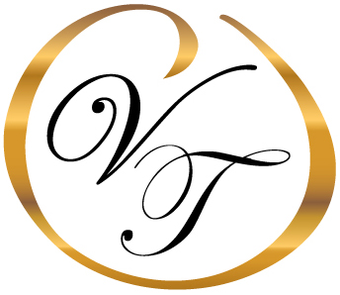
Items of Information Required for Arrangement Conference
Vital Statistical Information for Completion of Death Certificate

- Legal Name/Alias Name(s)
- Date of Birth
- Place of Birth – City & State/or Foreign Country
- Social Security Number
- Parents Names – Including Mother’s Maiden Last Name
- Employment – Job Title & Industry
- If Veteran – Discharge Papers (Only copies required not original)
- Educational Level – High School, College, Advanced Degrees
Information Required for Obituary Notice

- Job Title, Employer Name, City & State, Years of Employment, and Retirement Year
- Social Clubs, Organizations, Church Affiliations, and Educational Accomplishments
- Veteran – Rank, War(s), Branch of Service, Medal(s), Areas of Service
- Charitable Contribution(s)
Required Items if Selecting Visitation

- Photo(s) – for hairdressing purposes and a Memorial DVD
- Clothing & Undergarments – Preferably with high neck region and long sleeves
- Hair Dye & Make-up for female – lipstick and nail polish if necessary (favorite colors worn)
- Shoes are optional
Information for Veterans

- 5% Discount for Veterans and Spouses for At-Need and Pre-Need Arrangements
- Honorable Discharge entitles veteran and spouse to burial in a VA Cemetery
- Washington Crossing National Cemetery, Newtown, PA is local VA National Cemetery
- Free Grave, Opening, Marker, Flag & Honor Guard, and Vault if selecting Burial with a Casket
- Free Grave, Opening, Marker, Flag & Honor Guard, and Niches are available for cremated remains
- (There are size restrictions for urns being placed in Niches)
- Honor Guard, Burial Flag & Marker is free for all veterans if selecting burial in a private cemetery
- Most private cemeteries have a foundation and setting fee for a VA Marker
If Selecting Cremation

- Identification is required prior to cremation occurring
- Rental Casket/Wooden Casket/Alternative Container used if selecting Visitation prior to cremation
- Coroner’s Cremation Permit is Required prior to Cremation – Current Fee in Bucks County is $50
- Must wait 24 hours in the State of Pennsylvania before cremation can occur
- Most cemeteries allow cremated remains to be buried above an existing family grave or several in a new grave
- Some cemeteries require an urn vault when burying cremated remains in a grave space
- Death Certificates are currently $6 each in the State of Pennsylvania

www.varcoethomasfuneralhome.com 344 North Main Street, Doylestown, PA 18901 Phone (215) 348-8930 Fax (215) 348-0680

